**Access to the Electronic Resources/Databases/Research Information**

Since the website was updated, you might have noticed that there is no longer a link called “Databases.” That link used to house an alphabetical list of our electronic resources.

Now, you can find that same list by following these steps:

Click on “Electronic Resources” on the left side of the website.

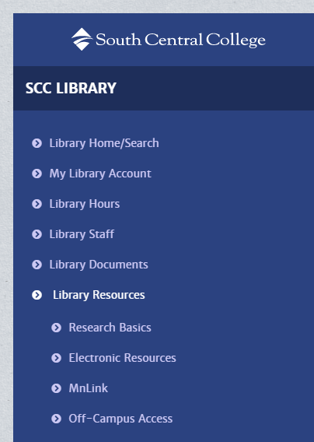

Then, click on “All” on the next screen.

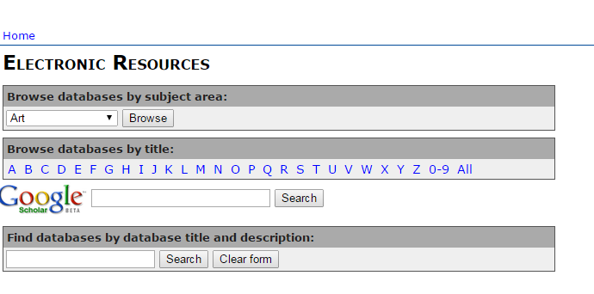

That should give you a list of all the electronic resources to which we provide access.

As always, if you have any questions (or suggestions!) we’d love to help.